**Surprise Test-2.1**

**Student Name:** Vivek Kumar  **UID:** 21BCS8129

**Branch:** BE-CSE (LEET) **Section/Group:** 809/A

**Semester:** 4th **Date of Performance:** 04/04/2022

**Subject Name:** Principles of AI  **Subject Code:** 20CST-258

**1. Aim/Overview of the practical:**

Explain property inheritance algorithm with example.

**2. Theories:**

**Inheritable knowledge:**

Relational knowledge is made up of objects consisting of

1. attributes
2. corresponding associated values.

**We extend the base more by allowing inference mechanisms:**

1. Property inheritance
   1. elements inherit values from being members of a class.
   2. data must be organised into a hierarchy of classes.

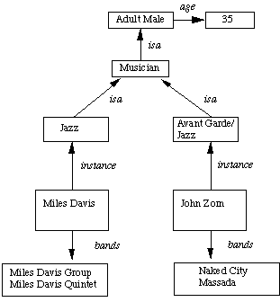

1. Boxed nodes -- objects and values of attributes of objects.
2. Values can be objects with attributes and so on.
3. Arrows -- point from object to its value.
4. This structure is known as a slot and filler structure, semantic network or a collection of frames.

**The algorithm to retrieve a value for an attribute of an instance object:**

1. Find the object in the knowledge base
2. If there is a value for the attribute report it
3. Otherwise look for a value of instance if none fail
4. Otherwise go to that node and find a value for the attribute and then report it
5. Otherwise search through using isa until a value is found for the attribute.

**Evaluation Grid (To be created as per the SOP and Assessment guidelines by the faculty):**

|  |  |  |  |
| --- | --- | --- | --- |
| Sr. No. | Parameters | Marks Obtained | Maximum Marks |
| 1. |  |  |  |
| 2. |  |  |  |
| 3. |  |  |  |
|  |  |  |  |